**WATEREUROPE ENGINEERING REPORT**

Nishant Rajpoot

Master’s in applied computer science

WaterEurope 2020

**PART ONE**

**How to produce 10y, 20y, 50y and 100y return period hydrographs estimation and associated flooded areas in the Var Lower Valley?**

# **Method of approach**

To produce a set of return period hydrographs, two key methods of approach were adopted: one based on discharge data, with a statistical approach and another based rainfall data adopting both a statistical and deterministic modelling approach. Such methods were selected to compare how the availability of different datatypes can affect the production of 10, 20, 50 and 100-year return periods and assess which approaches are most useful and reliable for estimating flooding within the Var Lower Valley.

**My contribution in this task:**

I worked on Flood Frequency Analysis estimation technique. For this we used two approaches, Gumbel method and Normal distribution. I wrote the code in Rstudio by using the equations of Gumbel and normal distribution respectively and generated the ‘Reduced variate’-‘Discharge’ graph for both the cases. Also, rainfall data was provided to us from 1975 to 2018, so we compared the two cases, 43 years v/s year 1994 (extreme case).

## **Discharge data**

### **Flood Frequency Analysis (FFA)**

Flood Frequency Analysis (FFA) is the estimation of how often a specified flood peak discharge will occur. Analysis requires the fitting of a probability distribution model to a sample of annual flood peaks, ideally over a sufficient period of observation (Bhagat, 2017). To estimate the flood peak discharges for the different return periods (10y, 20y, 50y and 100y), two different statistical methods, Gumbel and Normal Law, were employed using an observed daily discharge timeseries for the river Var. The timeseries extended from 1975 to 2018 but with missing data for 2002 – 2005 and 2007.

#### **Gumbel method**

The Gumbel distribution is a commonly used statistical method for estimating flood events (Haan, 1997), based on the distribution of extreme events and the use of frequency factors. The cumulative distribution function (cdf) of the Gumbel distribution is expressed in Equation 1:

$$F\left(x\right)=exp⁡[-\exp{(-\frac{x-a}{b}})]$$

Equation 1: Cumulative distribution function of the Gumbel distribution

The peak discharges were ranked in ascending order, and the Hazen formula (Hazen, 1914), shown in Equation , was used to obtain an empirical cumulative frequency for each rank, or the probability of non-exceedance.

$$F\left(x_{\left[r\right]}\right)= \frac{r-0.5}{n}$$

Equation 2: Hazen formula

#### **Normal distribution**

The Normal distribution defined by the mean (μ) and standard deviation (σ) was used as an alternative method of distribution for the FFA and follows a similar approach to the Gumbel distribution method. The standard deviation was calculated as per Equation , where n is the size of the sample.

$$σ= \frac{\sqrt{\sum{{(Xi-μ)}^{2}}}}{n}$$

Equation 3: Normal distribution

The reduced variate, u, for the normal distribution is given by Equation 4.

$$u= \frac{(x- μ)}{σ}$$

Equation 4: Normal distribution equation with reduced variant

#### **Regression Analysis**

Following the calculation of the reduced variates, u, for both the Gumbel and Normal distributions, the reduced variate, u, for each was analyzed graphically in a plot of discharge (m3/s) against the reduced variate. The discharge was obtained from the corresponding non-exceedance, F(x), for each reduced variate, u. Where the reduced variate, u, is described as:

$$u = -In(-ln F(x) )$$

Equation 5: Regression analysis formula

Using the assumption that the expression for a given quantile, or non-exceedance, F(x), corresponds to the reduced variate, u, a regression line for both the Gumbel and Normal distributions was computed using the defining parameters for each distribution; $α$, $β$ and $μ$, $σ$, respectively. This regression line was then used to relate discharge to reduced variate and extrapolated to estimate the peak discharge for the probability of non-exceedance, F(x) relating to the 10, 20, 50 and 100-year return periods. The return period (T) of an event is defined as the inverse of the occurrence rate, $1-F(x)$, Equation 6.

$$T= \frac{1}{1-F(Xi)}$$

Equation 6: Regression analysis formula with reduced variant

The regression line for each distribution was then compared to the observed discharges for the reduced variate. As shown in **Error! Reference source not found.**Figure 1 and Figure 2 the Gumbel distribution offers the best method for the FFA, as the extrapolation of the reduced variate and discharge relationship is more closely aligned to the observed values than approximated by the Normal distribution.

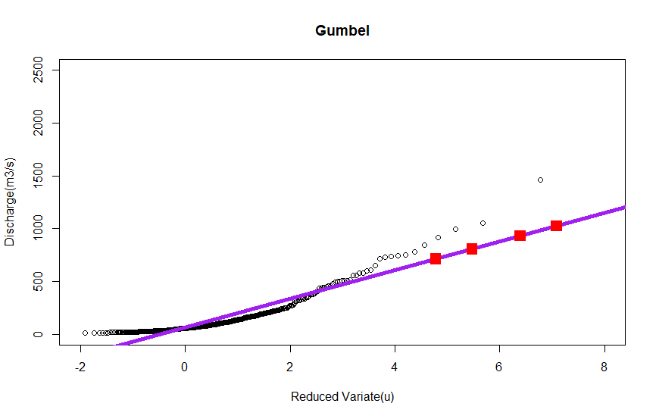

Figure1: Graphical analysis of the Gumbel distribution. Observed discharges are represented as black circles with the computed regression line for the Gumbel distribution in purple. The red squares pin-point the 10, 20, 50 and 100 year return periods.

As such the values obtained for the 10, 20, 50 and 100-year return periods using the Gumbel approach were used in subsequent analysis.

Figure 2: Graphical analysis of the Normal distribution. Observed discharges are represented as black circles with the computed regression line for the Normal distribution in purple. The red squares pin-point the 10, 20, 50 and 100 year return periods.

**PART TWO**

**What are the uncertainties in 1D hydraulic modelling for the Var lower valley (riverbed, floodplain, input hydrographs, roughness, weir coefficients, geometry, sea level? …)**

# **Method of approach**

To understand and explain the uncertainties in 1D hydraulic modelling, Mike 11 was used as the modelling platform. The uncertainties in the hydraulic modelling of the Var lower valley was analyzed mainly by varying the following parameters in Mike 11:

1. Riverbed
2. **Geometry**
3. Input hydrographs (Upper boundary conditions)
4. Sea level (Lower boundary conditions)
5. Roughness
6. Weir coefficients
7. Theoretical basis
8. Flood plain
9. Measurement data
10. Temporal simulation time
11. Flood dynamic effects

Out of the parameters listed, 1-7 were modelled and the rest are explained theoretically.

**My contribution in this task:**

In week 2, I worked on one parameter, which was **Geometry**, out of 7 different parameters of uncertainties. This type of uncertainty is associated with the shape of the cross section of rivers. Sources of uncertainties due to geometry are Shape and number of cross-sections and DEM resolution. Higher the resolution DEM provides great detail and vice versa. We decided to go for two shapes, triangle and trapezoid and then compare it with original. By using Mike Zero, I deleted the all the internal point, except two extreme and one center for Triangle and for Trapezoid, two extremes and two centers. Then, I saved the ‘.Res11’ file of all three cases and then using Mike view we plot the graph for comparison.

# **Uncertainties due to geometry**

This type of uncertainty is associated with the shape of the cross section of rivers. Sources of uncertainties due to geometry are:

## **Shape and number of cross-section**

Shape of the cross section is a source of uncertainty due to geometry. The shape used to simulate a 1D model should sufficiently represent the real cross sections. The number of the points representing the cross section is also an important factor contributing to uncertainty. Higher number is a better reflection of the real cross section.

## **DEM resolution**

DEM resolution is another source of uncertainty in representing the geometry. Low resolution DEM represents the shape of the cross-section very smoother while the higher resolution captures all the details of the cross-sections.

To model the uncertainty in the geometry, two types of cross-section shapes were considered in Mike 11. The first type is triangular cross-section, an extreme case where just three points represent the shape. And the second type is the trapezoid shape, considered as the less complex shape. All the cross-sections along the river were converted to two different shapes. To convert the cross-section to triangular one, points of the cross-section in the cross-section file were reduced just to three points: the left and right bank and the lowest point of the cross-section. To change the cross-section to trapezoid shape, four points were selected, the left and right bank, the lowest point in the first and second half of the cross-section.

## **1.1.3 Results**

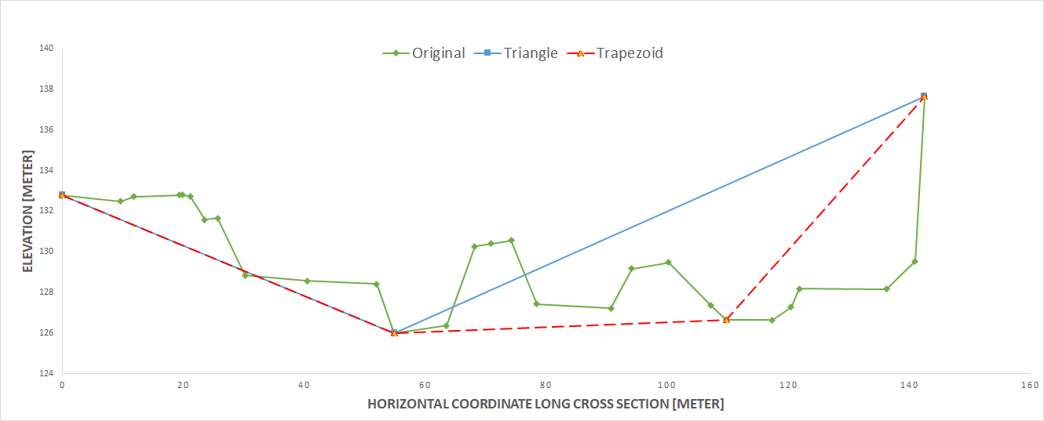

Figure 3: Cross section of the river and possible cross sections of triangular and rectangular shapes

The number of points representing the shape of cross section is a source of uncertainty in hydraulic modelling. Resolution of DEM data can be another source of uncertainty to obtain cross section data. Low resolution DEM provides smoother and less detailed data whereas high resolution DEM provides greater detail.

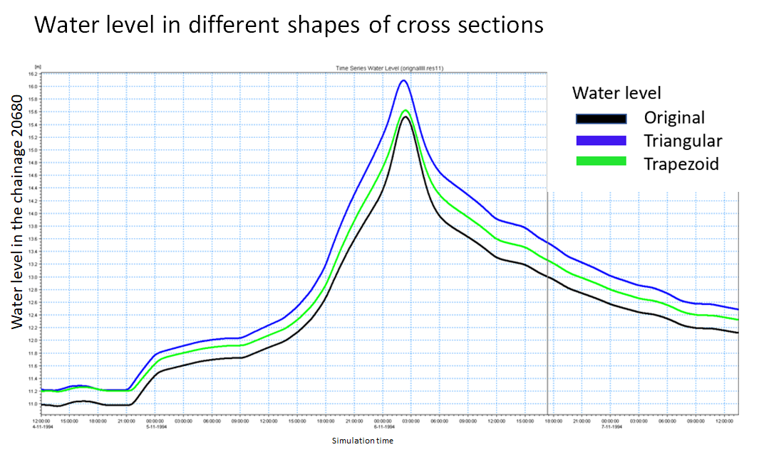

Figure 4: Water level at different shaped weirs

**Conclusion - Part 1**

To produce a set of return period hydrographs for the Lower Var, there are several methods of approach that can be taken depending on time and data availability. In the absence of reliably long time series, the IDF curve approach can be used to obtain a fairly reasonable set of return hydrographs in a short space of time. Statistical methods have potential to be useful, however, the distributions, Normal and Gumbel that were evaluated in this report proved unsuitable in the curation of return period hydrographs for the lower Var.

# **Conclusion - Part 2**

In this report, various factors that can develop uncertainties in 1D hydraulic modelling were tested. The parameters that were suitable to model in Mike 11 were used to model and analyse the results, whereas the ones that could not be modelled were analysed theoretically.